CSE3CAP Sprint Single Page Reporting Template

|  |  |
| --- | --- |
| Sprint # |  |
| Team Name |  |
| Team Project |  |

Team Burndown Chart (End of Sprint)

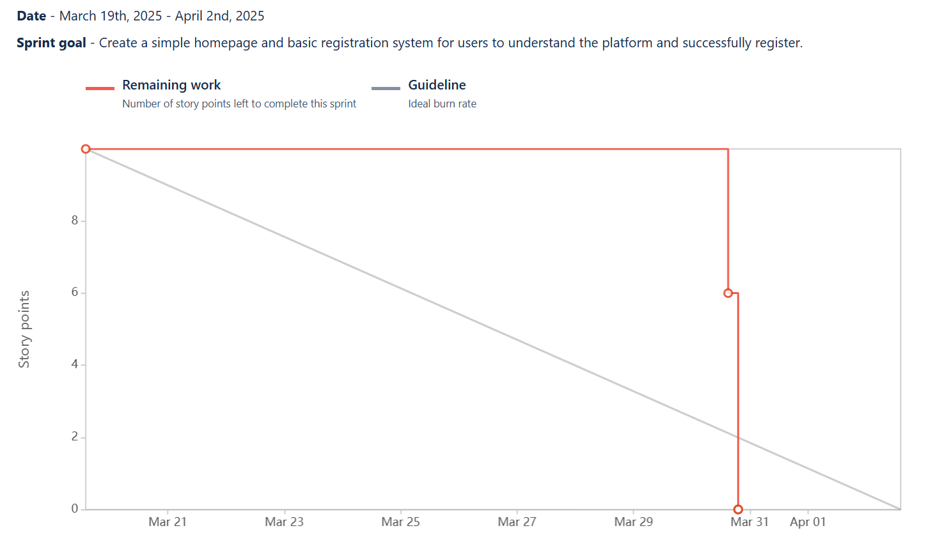

Completed Story Points / Allocated Story Points :

<INSERT YOUR COMPLETED STORY POINTS>/<INSERT TOTAL ALLOCATED TO YOU>

Individual Contribution Summary (150 words):

<INSERT A SUMMARY OF YOUR ACTIVITIES>

Retrospective thoughts on sprint (150 words) (Well done, Not Well Done, Improvement Focus):

<INSERT A SUMMARY OF YOUR REFLECTION>